MD2201: Data Science

Name of the student: Bhavin Patil Roll No. 78

Div: D Batch: B-3

Date of performance:

Experiment No.5

Title: Regression.
Aim: i. To construct a simple linear regression model
ii. To construct a multiple linear regression model.

Software used: Programming language R.

Data Set: Toy Sales Dataset

Code Statement:
- Simple Linear Regression
- Consider the Toy sales data set.
- Apply simple linear model considering response as Unit sales and explanatory variable as Price.
- Plot the scatter plot and draw the regression.
- What are values of R-square and residual standard error? (Write in conclusion)
- Display all predicted values from the designed model and the corresponding values of error.
- Multiple Linear regression:
- Consider Toy sales data set.
- Consider all variables to fit the regression model.
- Compare the R-square of SLR with MLR. (Write in conclusion)
- Which of the variable is more significant? Why? (Write in conclusion)
- Can you reject Null hypothesis for promotion expenditure variable? (Write in conclusion)
- Which scenario from the following you will select to be applied to get maximum number of Unit sales? (Write in conclusion)
- Price=9.1$, Adexp=52,000$, Promexp=61,000$
- Price=8.1$, Adexp=50,000$,Promexp=60,000$

Code:

#Simple Linear Regression
cat("Simple Linear Regression\n")
dataset <- read.csv("Toy_sales_csv.csv")
l1 <- lm(Unitsales~Price, dataset)
print(summary(l1))

#Scatter Plot
library(ggplot2)
p <- ggplot(dataset, aes(Price, Unitsales))+geom_point()+geom_smooth(method = "lm", formula = y~x, col="red", se=F)
print(p)

#Predicted Values

cat("\n\nPredicted Values\n")
pred1 <- predict(l1)
print((pred1))

#Error Values

cat("\n\nError Values\n")
er <- dataset$Unitsales - pred1
print(er)

#Multiple Linear Regression
cat("\n------------------------------------------------------------\n")
cat("\n\n\nMultiple Linear Regression\n")
l2 <- lm(Unitsales ~ Price + Adexp + Promexp, dataset)
print(summary(l2))

#Predicted Values
cat("\n\nPredicted Values\n")
pred2 <- predict(l2)
print(pred2)

s <- data.frame(Price = c(9.1,8.1), Adexp = c(52,50), Promexp = c(61,60))
pred2 <- predict(l2, s)
print(pred2)

Results:

Simple Linear Regression

Call:

lm(formula = Unitsales ~ Price, data = dataset)

Residuals:

Min 1Q Median 3Q Max

-3967.4 -1488.3 673.4 1529.6 2739.0

Coefficients:

Estimate Std. Error t value Pr(>|t|)

(Intercept) 114215.1 6695.9 17.057 3.60e-14 ***

Price -4913.7 821.9 -5.978 5.13e-06 ***

---

Signif. codes: 0 ‘***’ 0.001 ‘**’ 0.01 ‘*’ 0.05 ‘.’ 0.1 ‘ ’ 1

Residual standard error: 1997 on 22 degrees of freedom

Multiple R-squared: 0.619, Adjusted R-squared: 0.6017

F-statistic: 35.74 on 1 and 22 DF, p-value: 5.125e-06

Predicted Values

1 2 3 4 5 6 7 8 9 10 11 12 13

71219.97 70040.68 77362.13 78590.56 77853.50 72448.40 72939.77 75396.64 78590.56 71465.66 72939.77 74413.89 72939.77

14 15 16 17 18 19 20 21 22 23 24

77853.50 74905.27 73431.15 74413.89 73922.52 70040.68 74954.40 72448.40 75396.64 74954.40 73676.83

Error Values

1 2 3 4 5 6 7 8 9 10

2739.0295 1503.3239 1224.8708 1773.4391 917.4981 -462.4022 1945.2251 -2051.6384 -1931.5609 414.3431

11 12 13 14 15 16 17 18 19 20

658.2251 479.1070 -3936.7749 688.4981 -2362.2657 815.8524 1839.1070 -1340.5203 -1018.6761 1245.5970

21 22 23 24

-2747.4022 1608.3616 -3967.4030 1966.1660

------------------------------------------------------------

Multiple Linear Regression

Call:

lm(formula = Unitsales ~ Price + Adexp + Promexp, data = dataset)

Residuals:

Min 1Q Median 3Q Max

-2808.2 -263.8 256.3 667.6 2434.5

Coefficients:

Estimate Std. Error t value Pr(>|t|)

(Intercept) -25096.8 24859.6 -1.010 0.324773

Price -5055.3 526.4 -9.603 6.22e-09 ***

Adexp 648.6 209.0 3.103 0.005602 **

Promexp 1802.6 392.8 4.589 0.000178 ***

---

Signif. codes: 0 ‘***’ 0.001 ‘**’ 0.01 ‘*’ 0.05 ‘.’ 0.1 ‘ ’ 1

Residual standard error: 1275 on 20 degrees of freedom

Multiple R-squared: 0.8588, Adjusted R-squared: 0.8377

F-statistic: 40.56 on 3 and 20 DF, p-value: 1.085e-08

Predicted Values

1 2 3 4 5 6 7 8 9 10 11 12 13

73319.71 70866.02 76152.52 79699.84 78369.44 72725.92 73842.82 75795.30 77517.91 71055.98 73439.68 75094.58 71811.17

14 15 16 17 18 19 20 21 22 23 24

78309.53 74875.93 73289.60 76512.83 71965.73 69297.73 76252.82 69420.80 77246.94 70650.41 74685.76

1 2

72587.31 74542.75

scatter plot

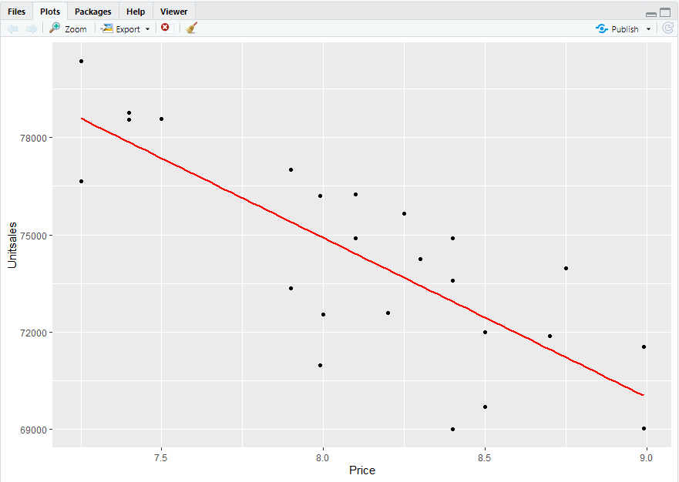

Conclusion: In this assignment we have successfully created a simple linear regression model and multiple linear regression model with predicted values and error values and a scatter plot showing the regression line for Unitsales for Toys.

